IBP2012-IVIS-006 Creating a List for a Replicated Yield Trial

Introduction:
A list of entries for a replicated yield trial can be assembled using the germplasm list creation tool by selecting entries from other lists or by importing a list from a germplasm import template. In this exercise we will select entries from a harvest list in Excel format and create an import template to make the final trial list.

Objectives:
At the end of this chapter, the user should be able to:
- Select entries from and excel file to include in the trial
- Import the list into the Breeding Manager
- Prepare the Replicated Yield Trial (RYT)

A. Importing a List of Germplasm for Trial Entries

Tutorial Steps:
- Open the harvest data file BF2011F3H.xls created in the last tutorial, and copy all entries labeled as Set 1 (112 entries) to a germplasm input template file (\ICIS5\Document\GermplasmLists\GermplasmList-template.xls). Save the File as BF2011MARS1.xls. (This file is already prepared as BF2011MARSet1_GermplasmList.xls in directory \ICIS5\Document\training\IVIS)

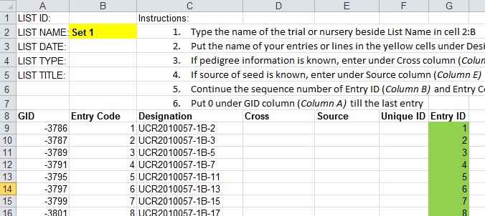
…
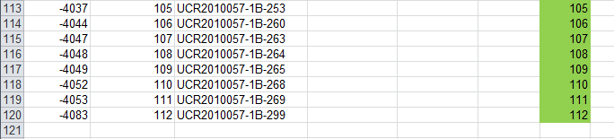

- Launch the Nursery Manager from the IB Workbench. Click the (g) icon to open the Germplasm List Creation page.

- Click on the Excel tab under Germplasm Sources. Open the file BF2011MARS1.xls created in step 1.

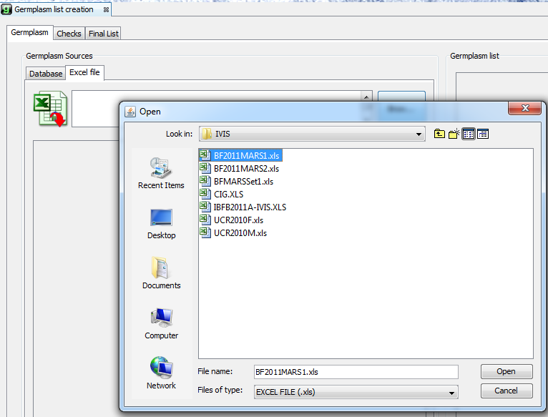

- Select all the lines in the left hand window and drag them to the right hand Germplasm List Window. Click Final List, enter BF2011MARS1 for the list name and “F3 Set 1 for 2011 MARS Phenotyping in Burkina Faso” for the description. Check the “Without checks’ radio button and click the save button.

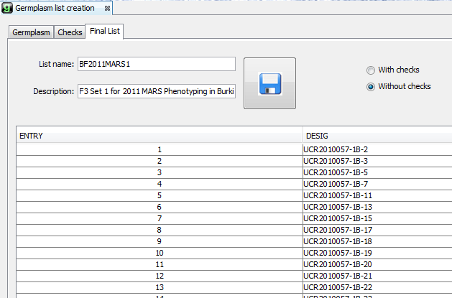

5. Close the Breeding manager.
B. Creating the Replicated Trial Fieldbook

Tutorial Steps

- Open the IB Fiedbook application from the IB Workbench. Open the tree for the Study BF2011MARS. Right click on Trials and select New Trial.

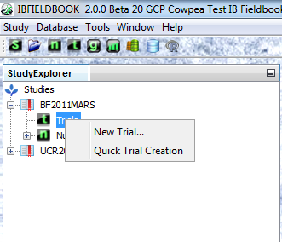

- Select the Cowpea_FUT_Template from the list of templates available.

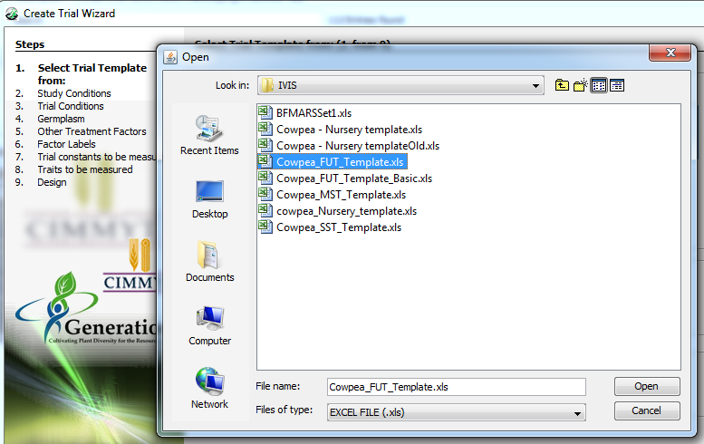

- Select Isa Drabo as the principal investigator and set the number of trial instances to 2. Click Next.

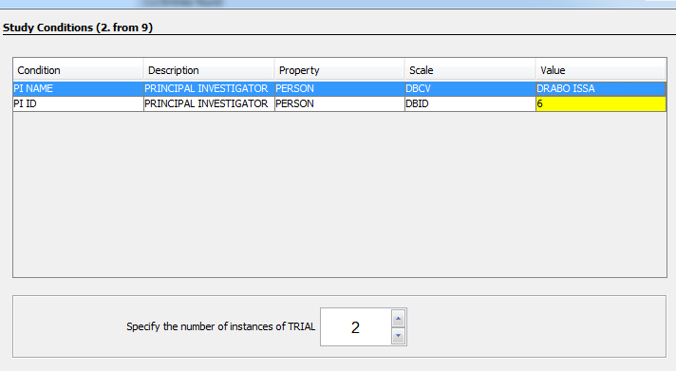

- Fill in the trial conditions: Isa Drabo as Cooperator for both locations, Pobe as location for the first trial, and Saria as location for the second trial.

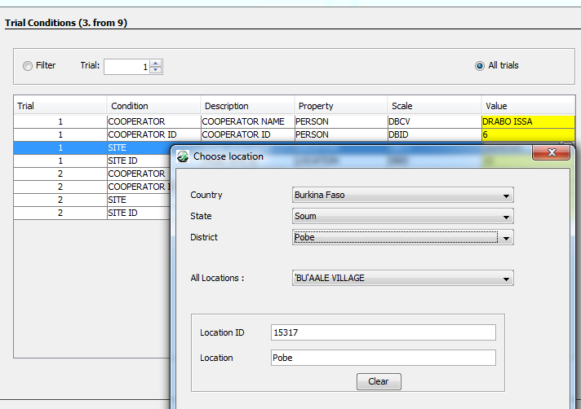

- Click Next and then select the list BF2011MARS1 for the germplasm entries.

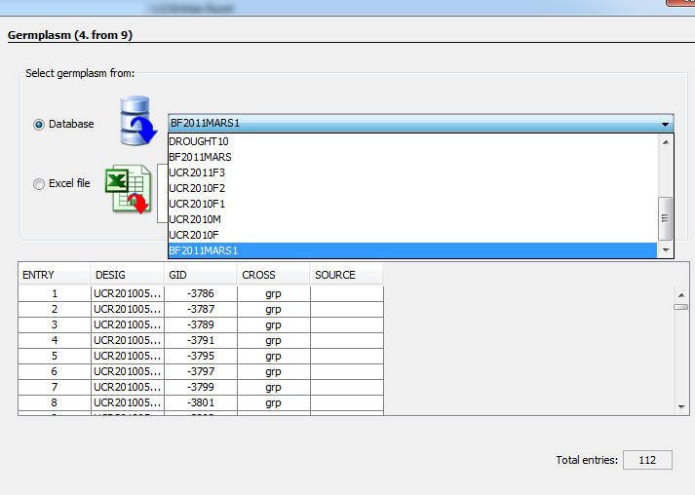

- Click Next and select PDATE and HARV D as constants to me recorded for each site.

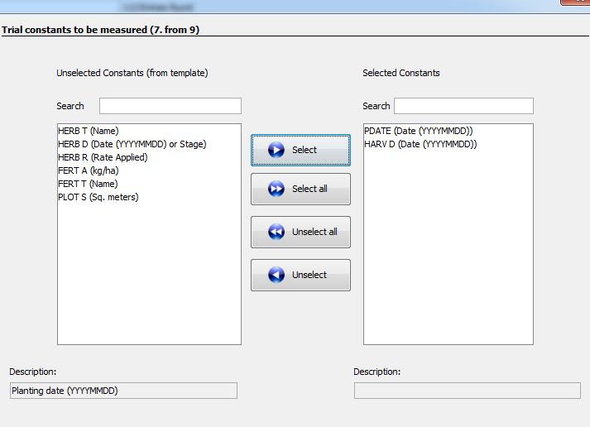

- Click Next and select the following traits for data recording: BB, FLOW50, MAT95, PSTAND, PODWT, SDHV, SDW100, VIRUSI and NOTES.

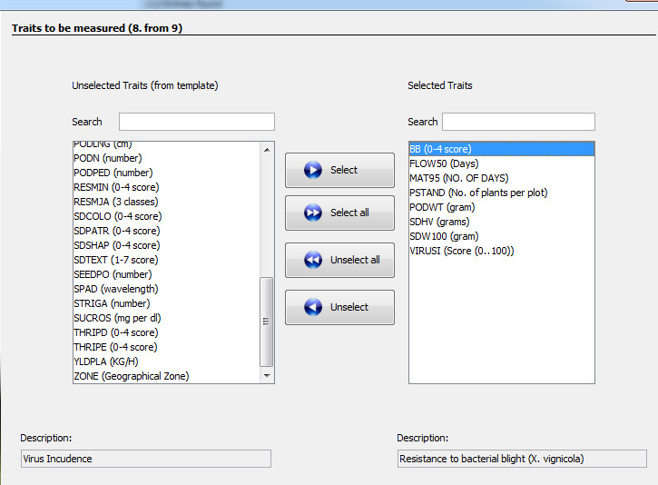

- Click next and pick “Use my own design” from the Design list. This allows users to import an existing randomization into the fieldbook from a template file. In this case the file is BFMARSSet1_Design.csv in directory \IVIS5\Document\Training\IVIS.

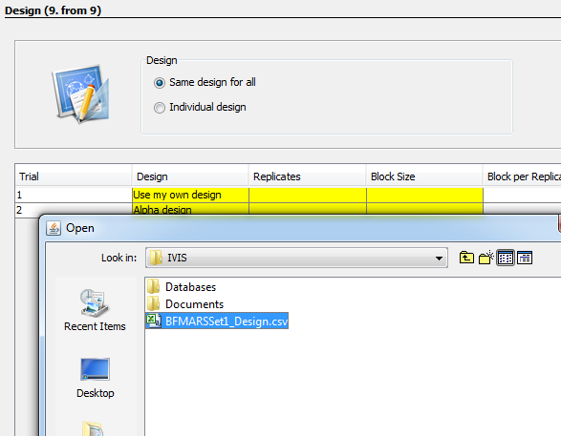

A design template must be a csv file with the following columns:

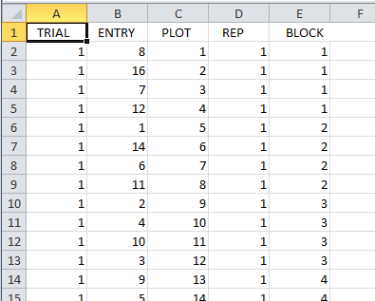

- Click Finish to see the Trial on the Measurements Tab. Enter the name ‘BF2011MARS1’ and click Save.

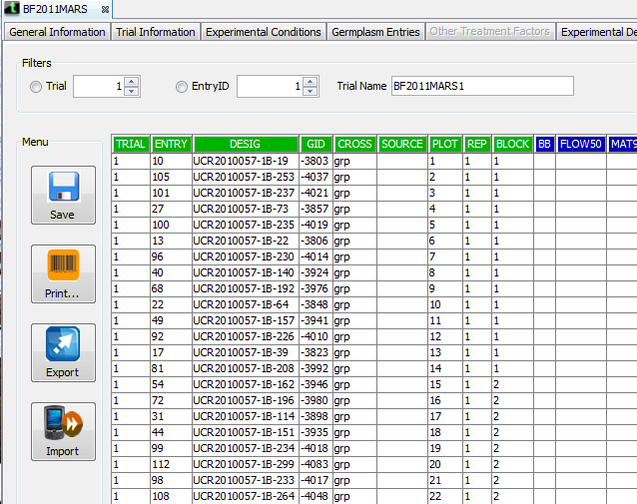

- Export the Fieldbook for data collection:

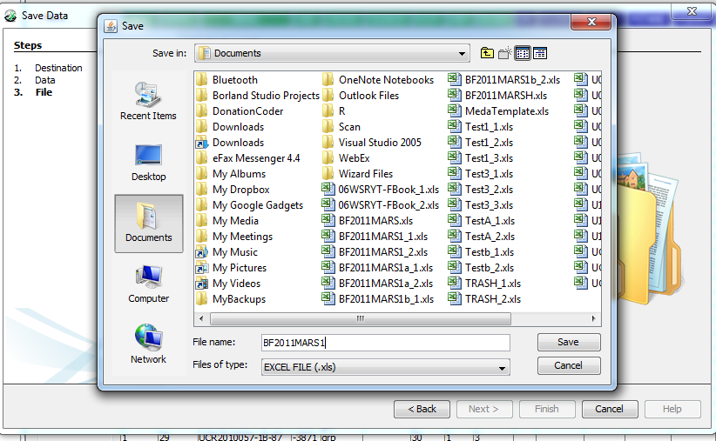

Close the IB Fieldbook Application.

C. Importing Data into the Study Database

After data is collected in the filedbook it can be imported into the Study.

Tutorial Steps
- Open the Ib Fieldbook from the IB Workbench. Expant the tree for the Study BF2011MARS, right click on the trial BF201MARS1 and select Open Trial.

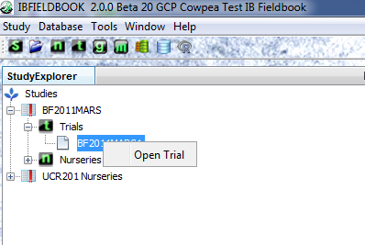

- On the Measurements Tab, Click Import and select Excel File.

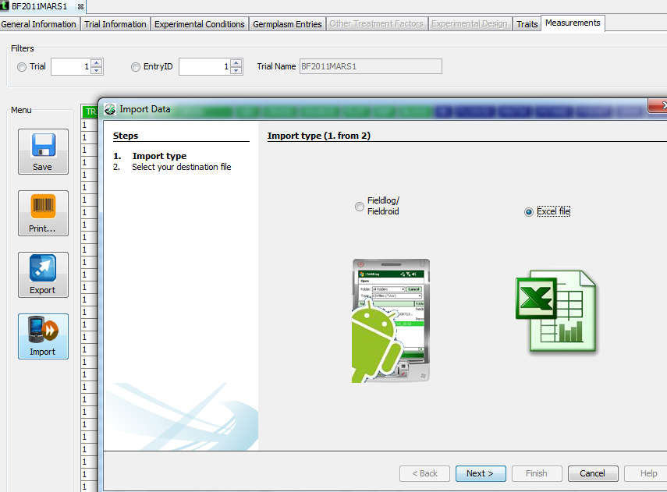

- Navigate to \ICIS5\Document\Training\IVIS and select file BF2011MARSSet1Pobe_Data.xls. Click Open to load the data. Repeat the process for file BF2011MARSSet1Saria_Data.xls.

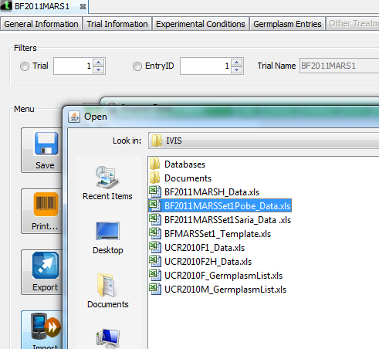

- Click Save to Save the data in the database:

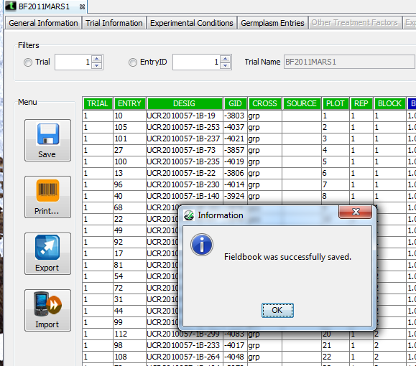

- Click Export and select Excel file to export the data for analysis

